Name of Student: Husam Ali Abdalla Nour | PRN:25070122086
Semester: III | Year : AY 2026-27
Subject: Programming with Java
ASSIGNMENT No : 12
TITLE : User-Defined Packages
Problem Statement
Write a Java program to create and use user-defined packages.
Learning Objectives
To create and use user-defined packages for organizing Java programs.

Programme
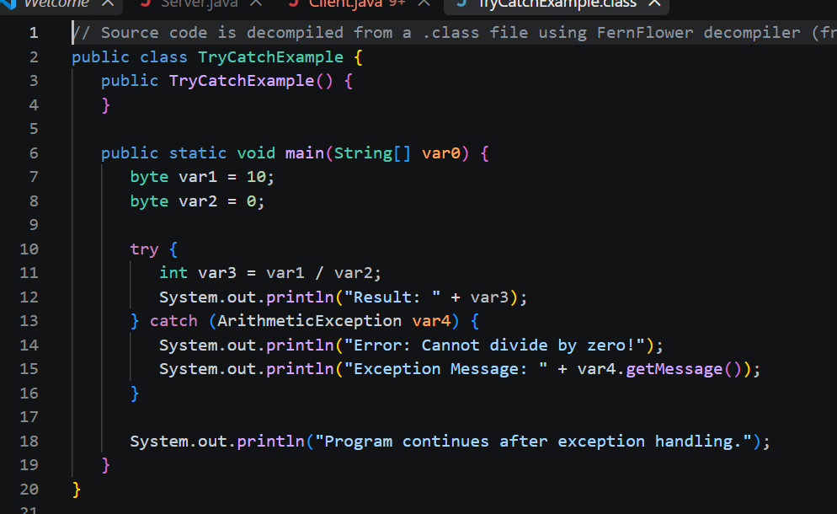
Practice questions
- Create a Java program by developing user-defined packages for a College Management System. Create separate packages for student and faculty details, and display their information using classes from these packages.
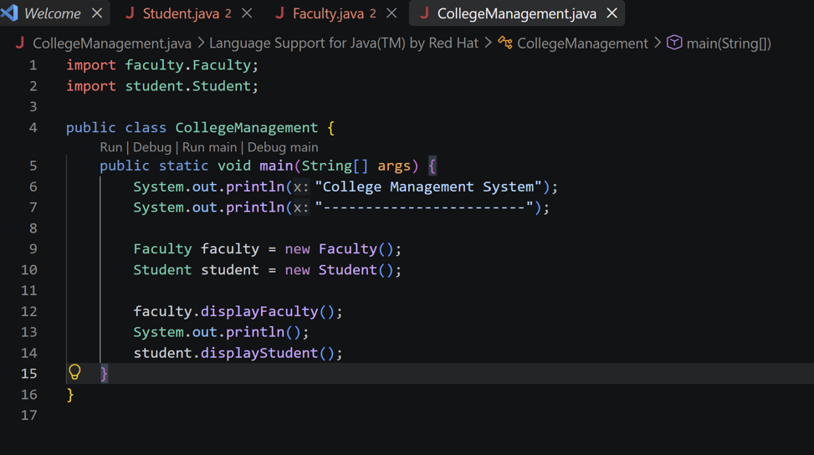
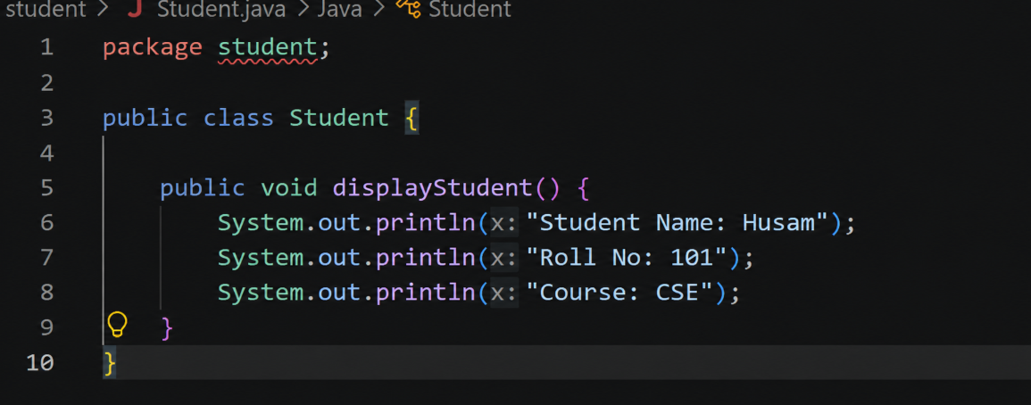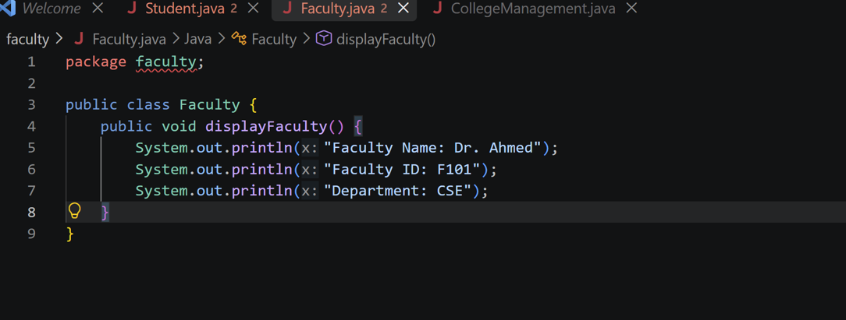
Output
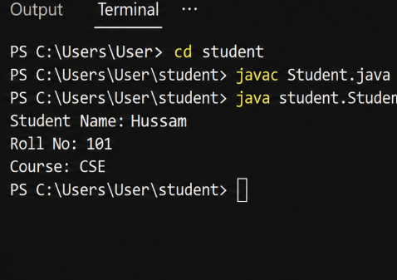
2. Create a Java program by developing a user-define package named Library that contains a class to store and display book details such as book ID, title, author, and price. Import the package into the main program and display the book information.

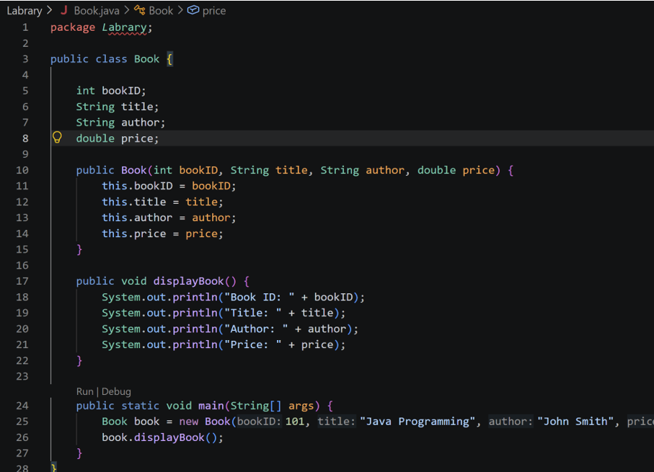

Output
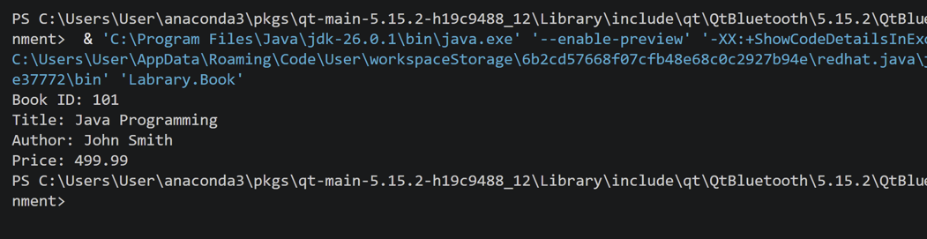
Conclusion
Packages help organize a Java project into logical, reusable units, prevent naming conflicts between classes, and support access control. Separating related classes into their own packages, as with the student/faculty and library examples, makes larger applications easier to structure and maintain .

